**CIS660 AUTHORING TOOL PROGRESS REPORT**

To be sent to SHL via email by midnight on Friday of each week

**WEEK OF:__________3__________**

**Name of Authoring Tool _______Interlocker_________________**

* Current date: _______03/19/2017___________
* Name: _______Jiongjian Chen___________

**Task Activities since the Last Report**

* Tell me what Design Doc work plan tasks you worked on over the past week

4. Construct LIG-graph

4.1. Implement conditions for a cycle of parts to be local interlocking (considering 3- and 4-part cycles)

4.2. Implement rules for expanding an existing LIG

* Tell me specifically what the work consisted of and what was accomplished

1. Implemented 3-part cycle and 4-part cycle conditions for local interlocking, in which Every non-key part should be immobilized and Every subset of two adjacent parts should be immobilized.

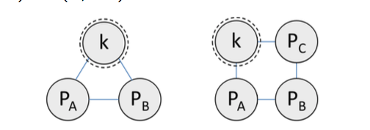

1. Solve for the construction of first LIG, which is G1, with a given user-specified primary key (k1) and an intended removal direction, which can be illustrated with this picture:

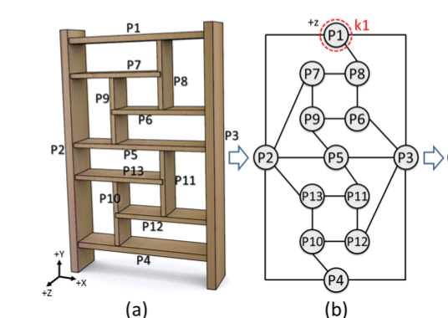

* List the number of hours you worked on each of these tasks this week

Implement conditions for a cycle of parts to be local interlocking – 3 hours

Implement rules for expanding an existing LIG – 4 hours

The construction of first LIG – 3 hours

* List the total number of hours you have spent working on your authoring tool since the start of the project

30 hours

**Activities Planned for Next Week**

Next week’s tasks are as follows according to the work plan(a little adjustment):

4. ConstructLIG-graph–3weeks

4.3. Implement three conditions for constructing LIGs with dependency in assembly order.

4.3.2. Construct Gj that shares parts with only one previously-constructed LIG, but not others

4.3.3. Construct Gj that shares parts with multiple previously-constructed LIGs.

**Work Plan Tasks Completed to Date**

1. Build Framework – 1week

1.1. Model interlocking furniture parts in 3d Max or Maya

1.2. Implement user GUI interface dialog (MEL)

1.3. Implement command plugin framework (C++)

1.3.1. Write code stubs

2. Construct Parts-graph – 2week

2.1. Generate initial parts-graph with given furniture model

2.2. Merge degree-1 nodes in the graph with their adjacent parts

2.3. Analyze and identify groups of overlapping cycles in the parts-graph

4. Construct LIG-graph

4.1. Implement conditions for a cycle of parts to be local interlocking (considering 3- and 4-part cycles)

4.2. Implement rules for expanding an existing LIG